

**IBM HACK CHALLENGE**

**2023**

**FINAL PROJECT REPORT ON**

**CROP YIELD PREICTION**

By

**TEAM INDUCE**

P. Varsha Bala

D. Chenna Keshava Reddy

D. Bhavani

N. Bhanu Tejaswini

31-08-2023

**CONTENTS**

1. INTRODUCTION

1.1 Overview

1.2 Purpose

2. LITERATURE SURVEY

2.1 Existing problem

2.2 Proposed solution

3. THEORITICAL ANALYSIS

3.1 Block diagram

3.2 Hardware / Software designing

4. EXPERIMENTAL INVESTIGATIONS

5. FLOWCHART

6. RESULT

7. ADVANTAGES & DISADVANTAGES

8. APPLICATIONS

9. CONCLUSIONS

10. FUTURE SCOPE

11. BIBILOGRAPHY

11.1 Source code

**1. INTRODUCTION**

**1.1 OVERVIEW**

Agrolytics is a web-based application that provides an overview of current state of the Indian Agriculture. The application has following modules: overview of Indian Agriculture, comparitive analysis between India’s and world’s agriculture, crop suggestion and yield prediction, challenges faced by Indian agriculture, employment opportunities and technological interventions that can be brought in the agricultural sector.

**1.2 PURPOSE**

Agriculture, as a base of human civilization, has continually evolved to meet the demands of a growing global population. With climate change, changing weather patterns, and limited resources posing challenges to agricultural productivity, the need for accurate crop yield prediction has become most important. To overcome this situation machine learning uses historical data of weather conditions, and soil conditions, it estimates the future yield. This empowers the farmers, policymakers, and supply chains in making informed decisions, enhancing resource allocation, and ensuring food security among changing environmental factors.

**2. LITERATURE SURVEY**

**2.1 EXISTING PROBLEM**

In India, though there are many third-party websites and organizations used to predict the crop yield they have used the traditional methods on historical data and statistical analysis. Some approaches also include remote sensing and satellite technology etc. The Space Application Centre (SAC) is already at an advanced stage of experimenting with the approach of Remote Sensing to estimate the area under principal crops through the scheme known as “Forecasting Agricultural output using Space, Agro-meteorology and Land based observations” FASAL (Forecasting Agricultural output using Space, Agro meteorology and Land). By combining these methods helps in understanding the diversified landscape, productivity and supporting the livelihoods of India.

**2.2 PROPOSED SOLUTION**

A web-based application in which the user can get the most suitable crop according to the climatic conditions of the selected state and the type of the soil using Machine Learning so that the user can get better yield. The user can also get the predicted crop yield according to the season and rainfall (current rainfall of each state is also displayed on the web application). Opportunities in the agriculture sector are also displayed. Seed requirement, availability and soil health cards are also displayed to help the farmers. Food security issues of a particular state and solutions to solve those problems are suggested. Problems faced by the farmers and solutions to those challenges are provided.

**3.THEORITICAL ANALYSIS**

**3.1 BLOCK DIAGRAM**

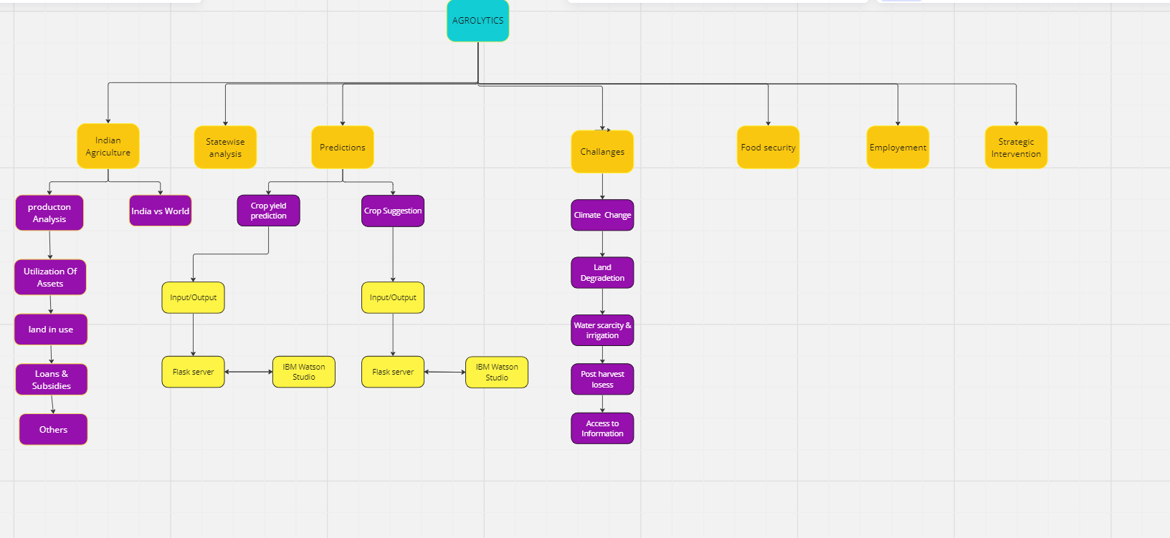

**3.2 HARDWARE/SOFTWARE DESIGNING**

* Front-end technologies like HTML, CSS, and React JS
* IBM Cognos Analytics for Data visualization
* Back-end technologies like Node JS, Flask, Machine Learning
* APIs like Topo-json, Rainfall and temperature API
* Red hat Open Shift for running flask application
* IBM Watson Studio and IBM cloud services to run ML models

**4. EXPERIMENTAL INVESTIGATIONS**

Our studies involve developing accurate models for forecasting agriculture. These projects include integration of various data sources such as historical crop yields, weather conditions and soil characteristics. Crop yield prediction models can benefit from ongoing improvement. Updating the models with new data and monitoring their performances helps to ensure accuracy all the time.

**5. FLOWCHART**

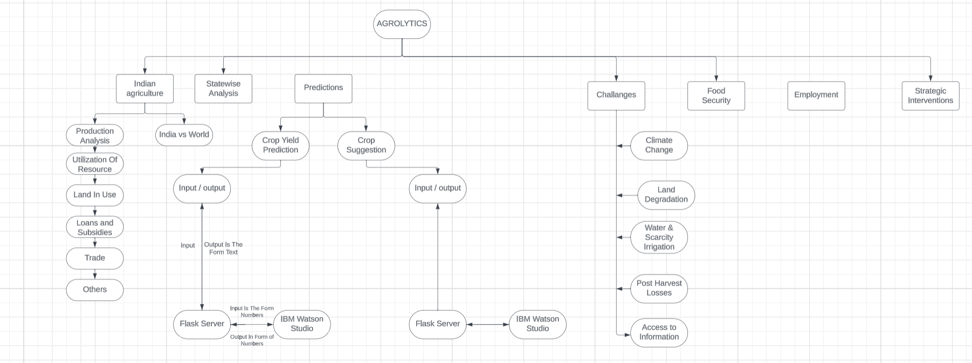

**6. RESULT**

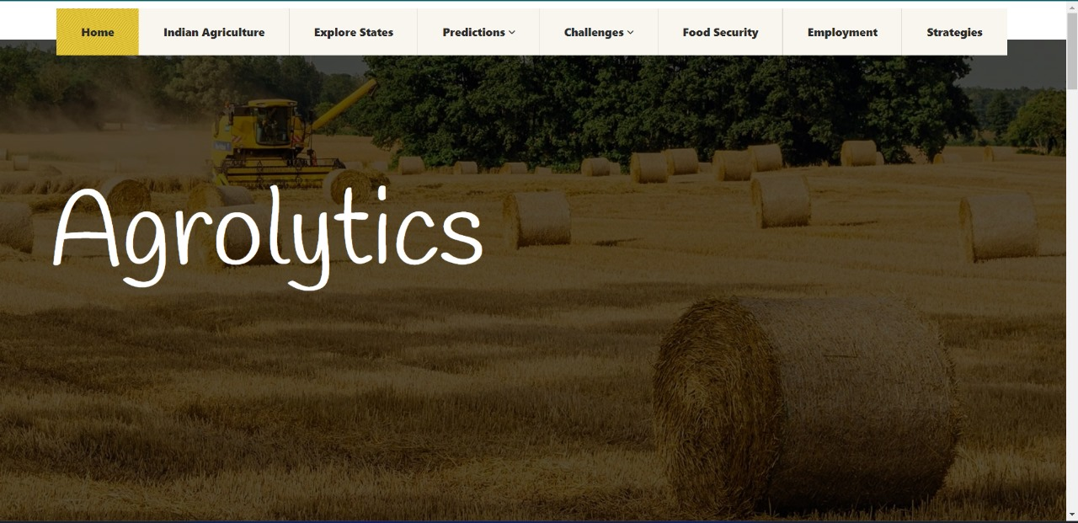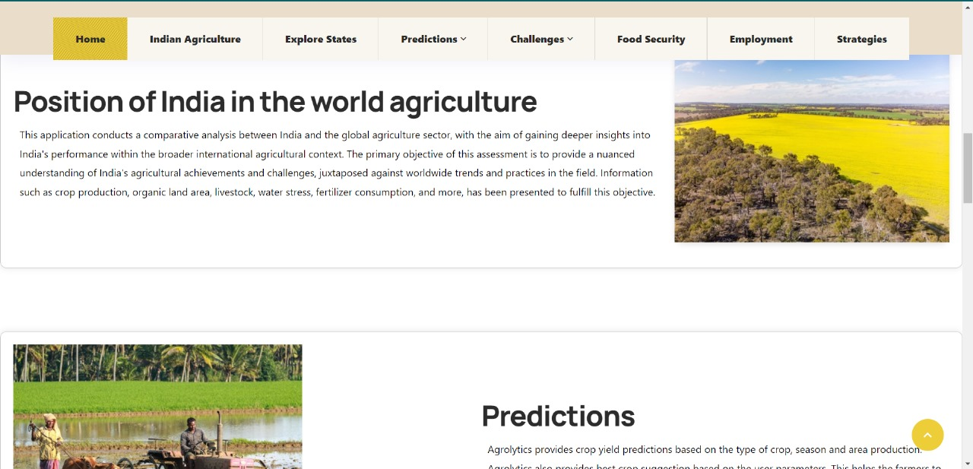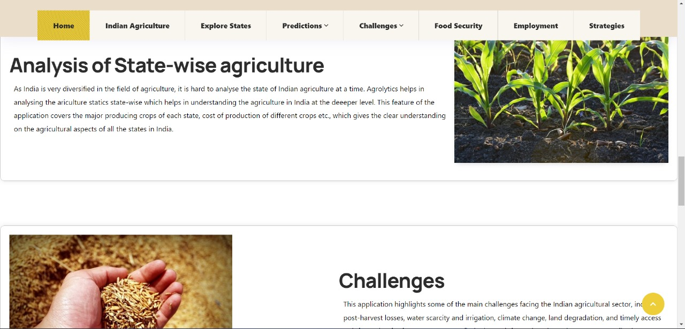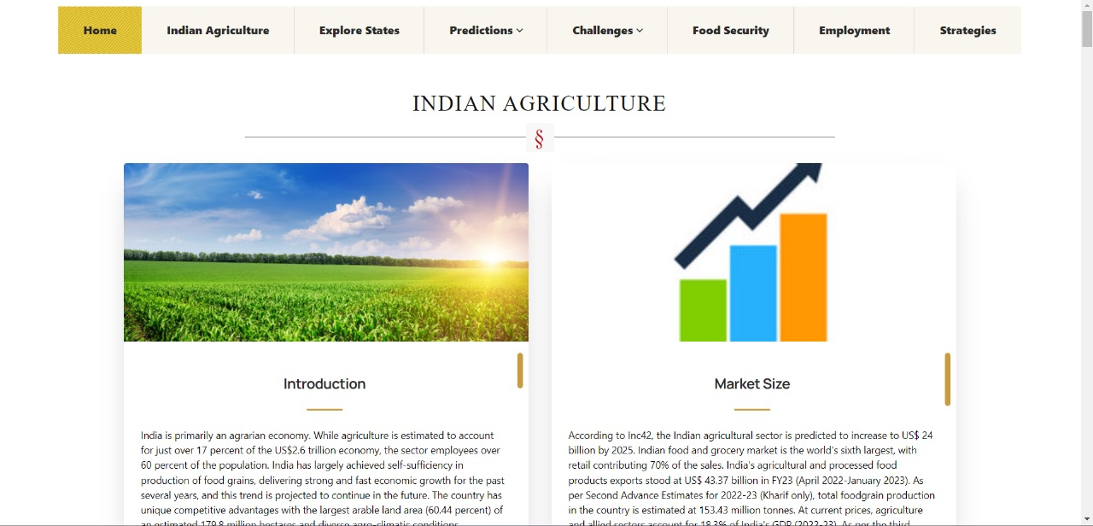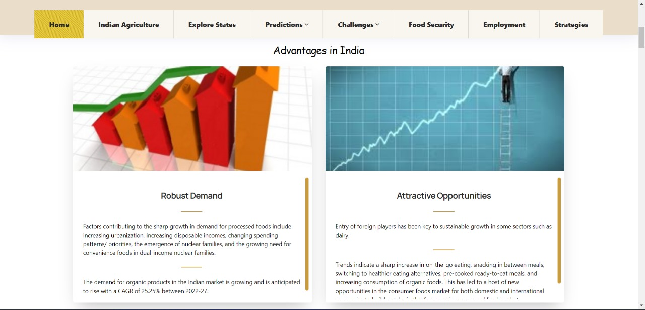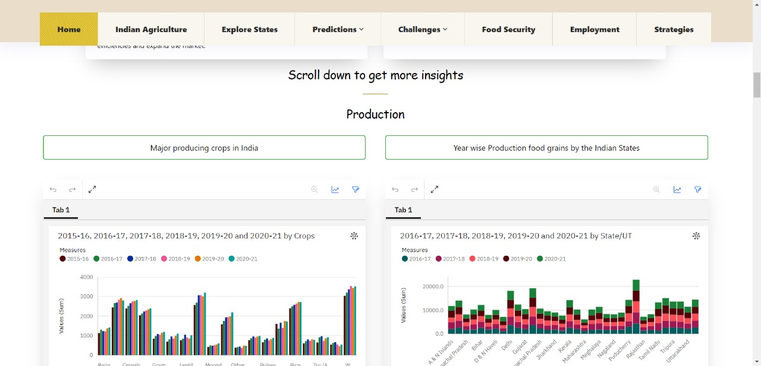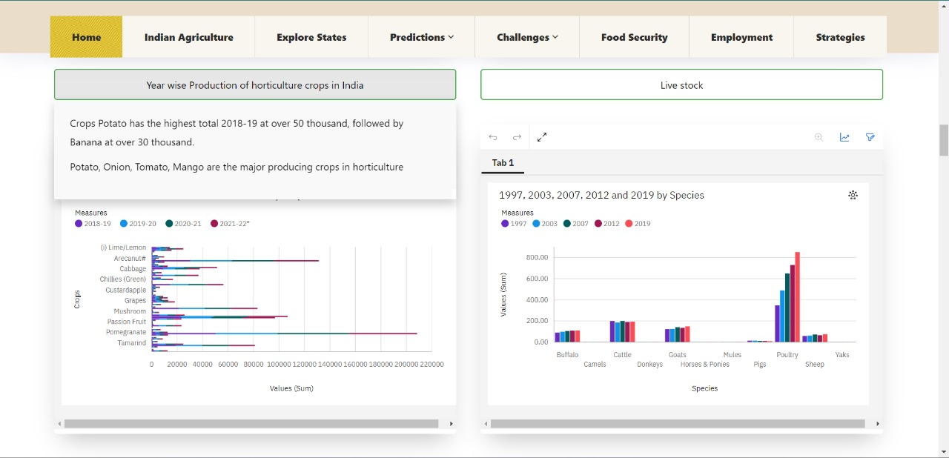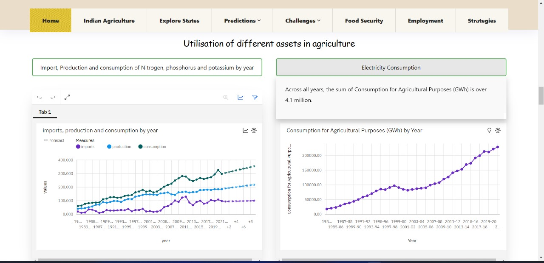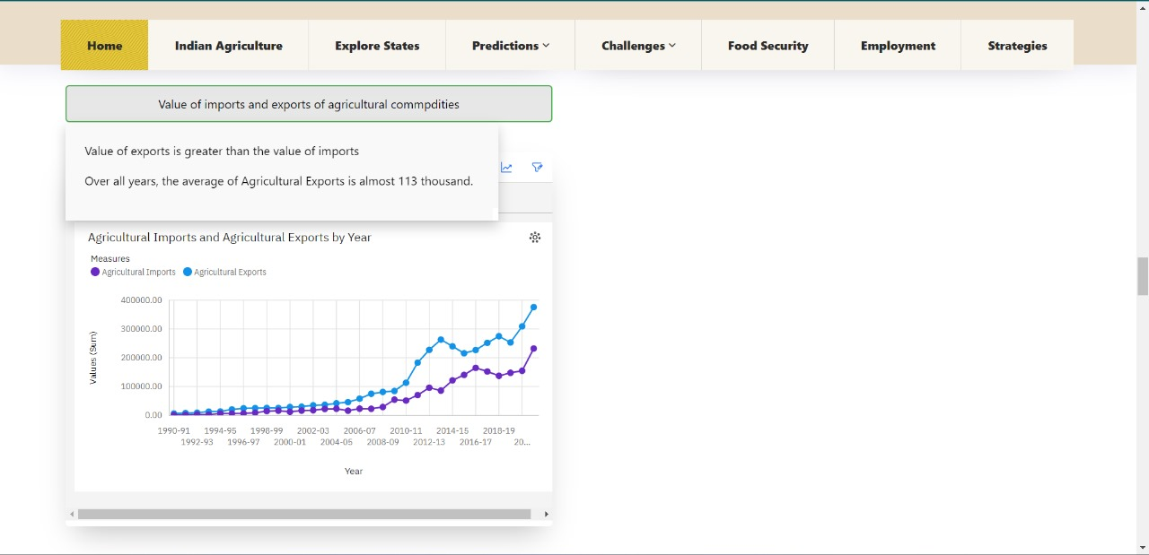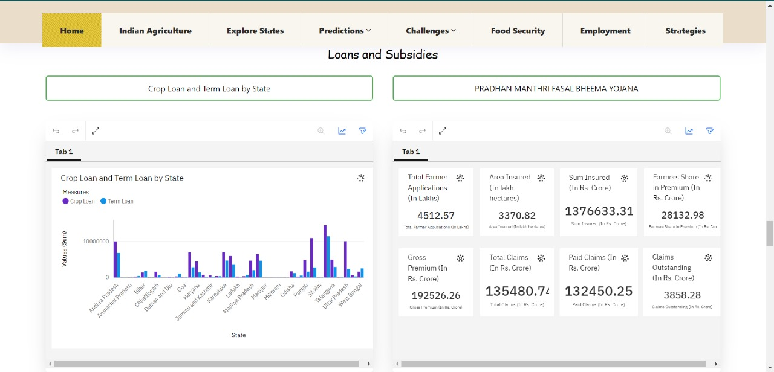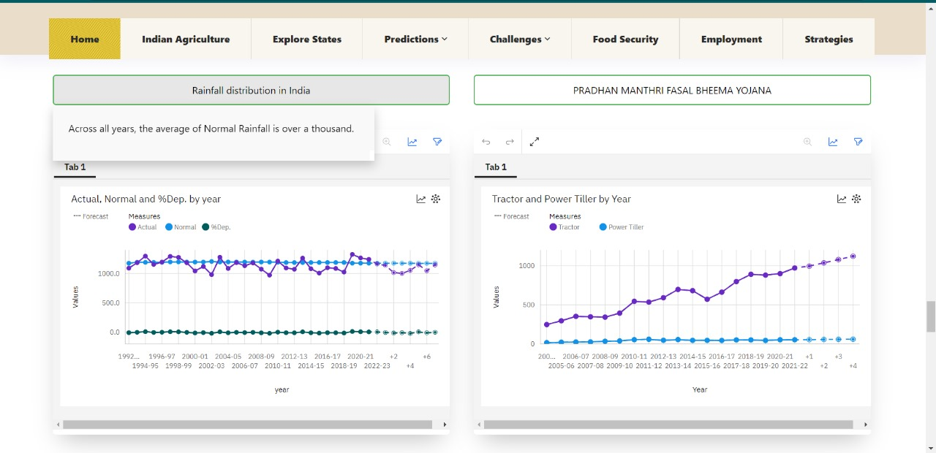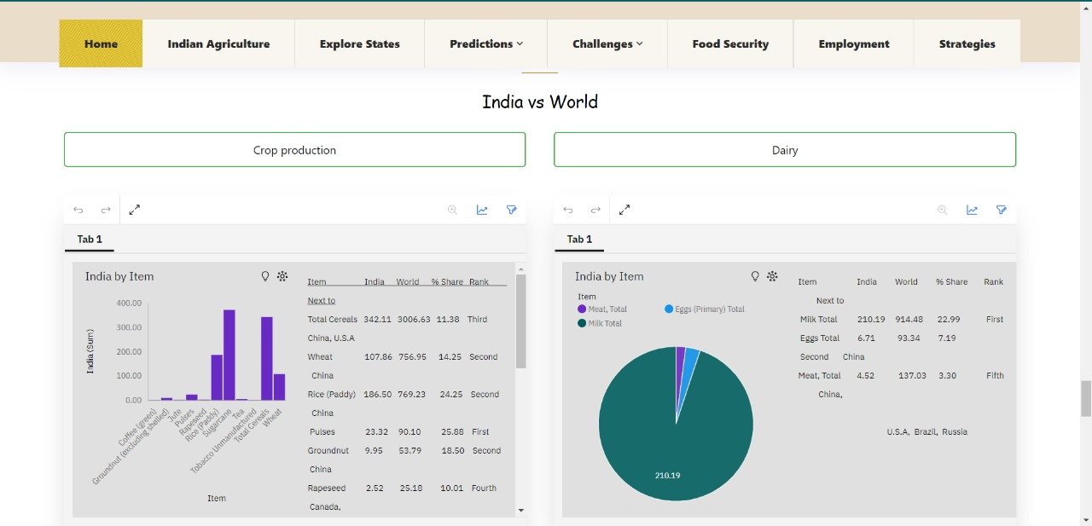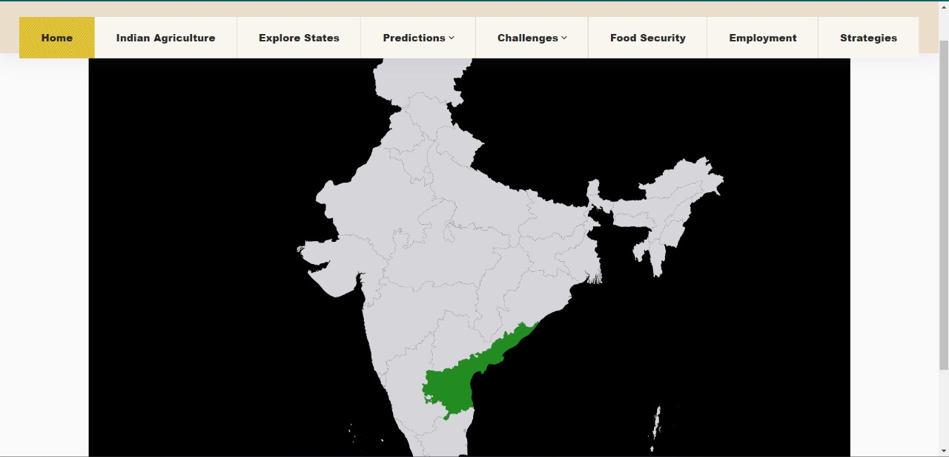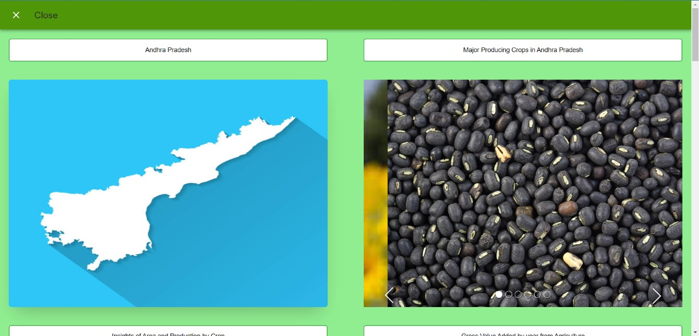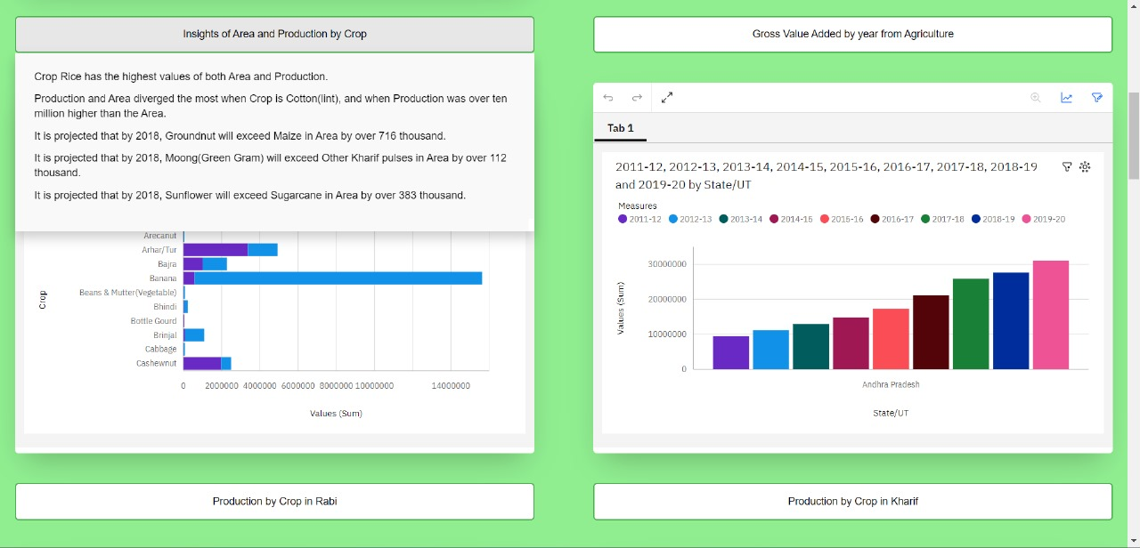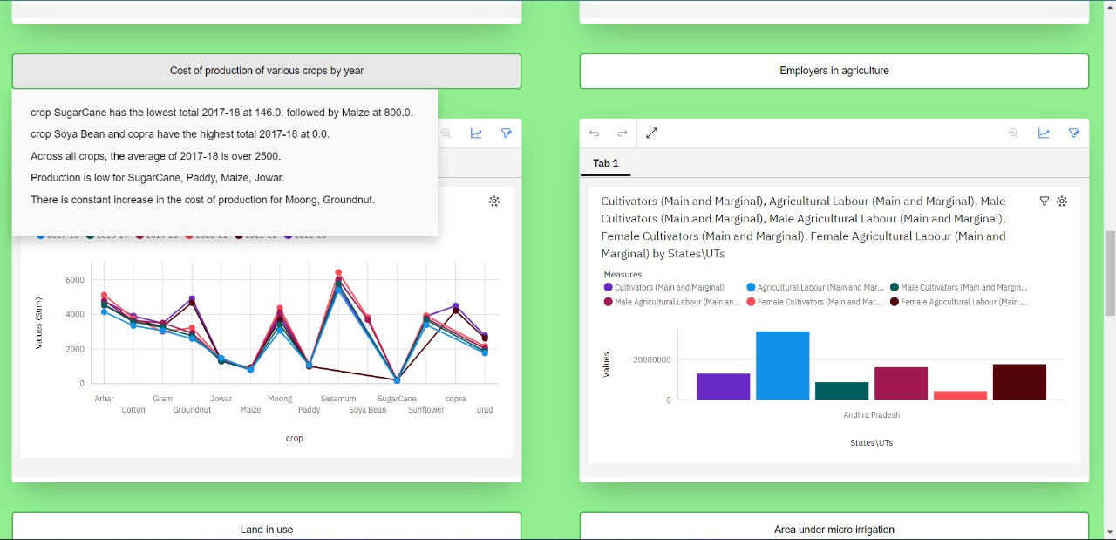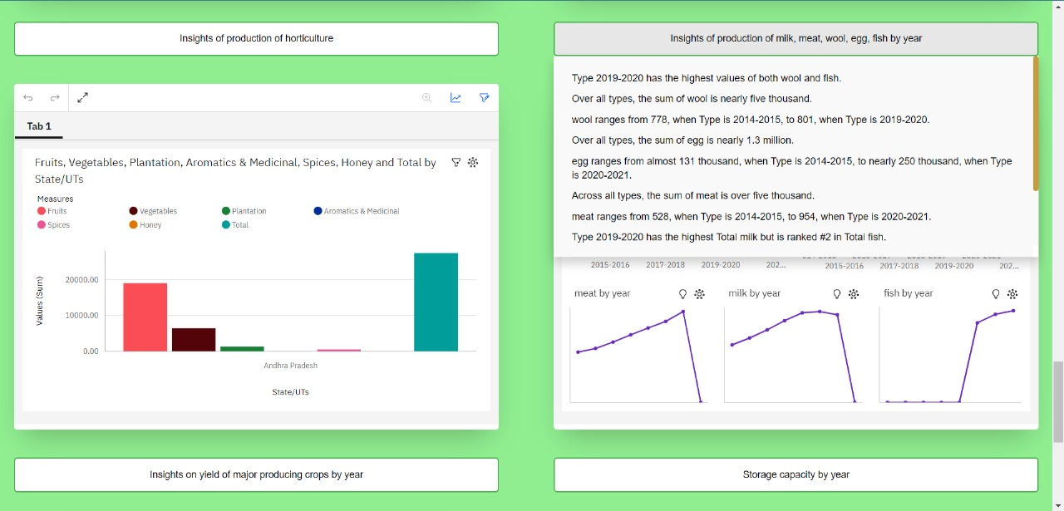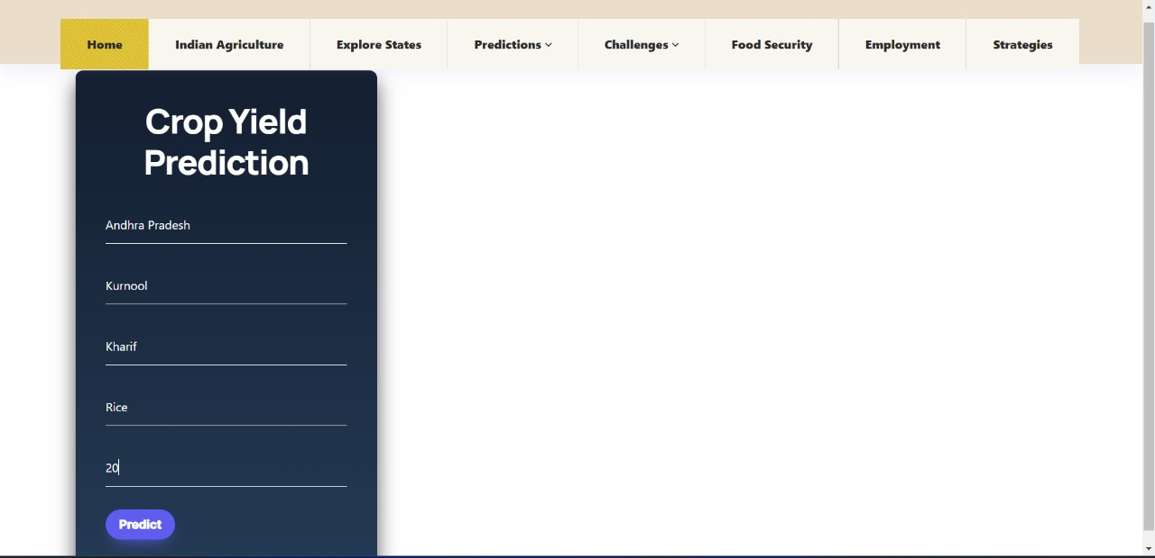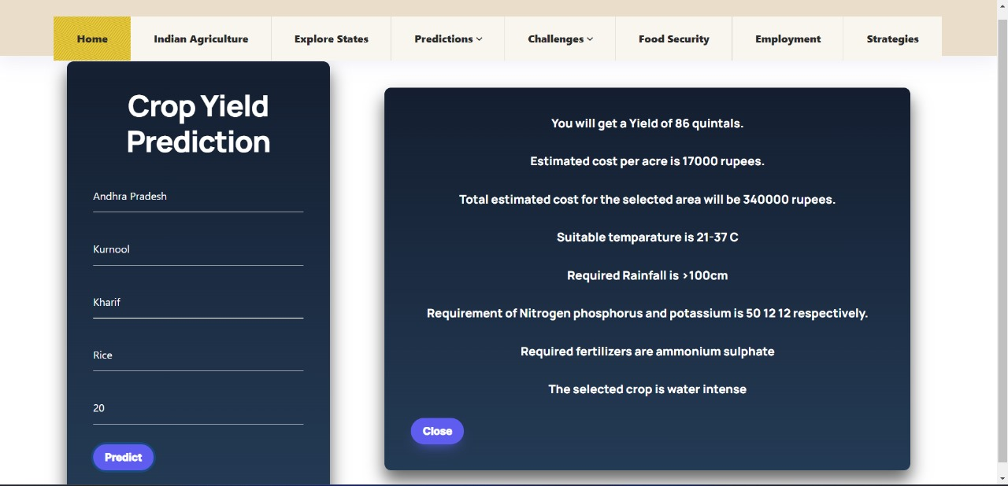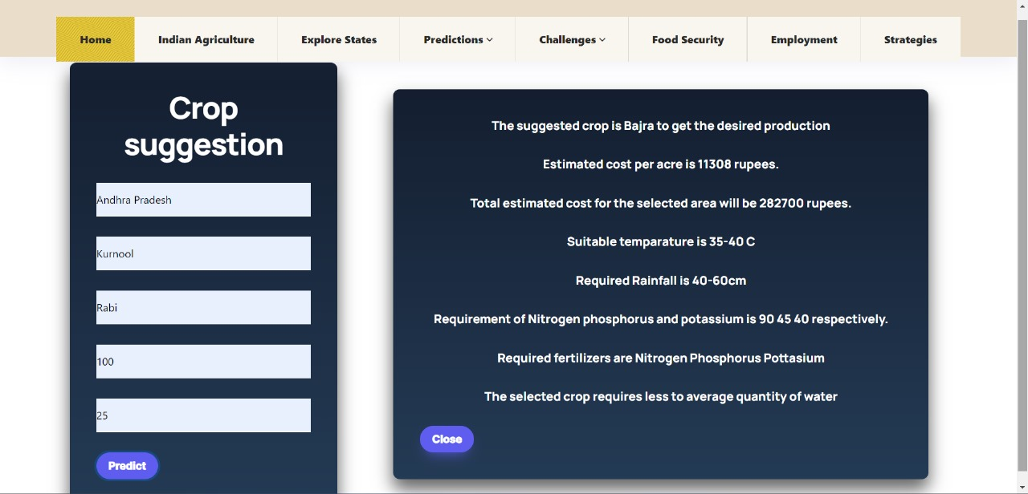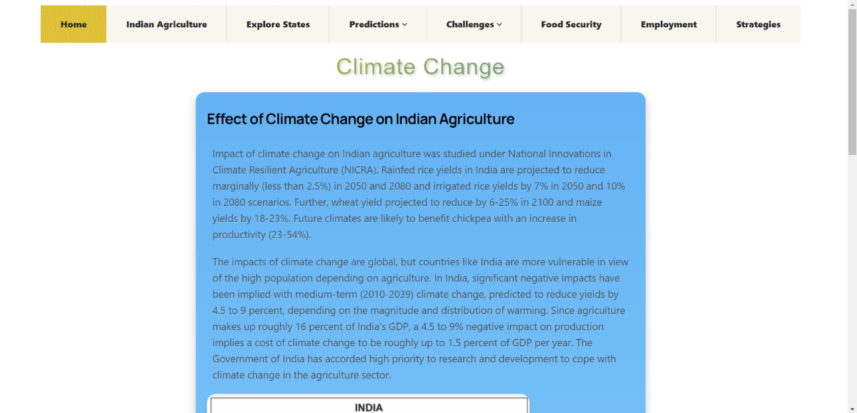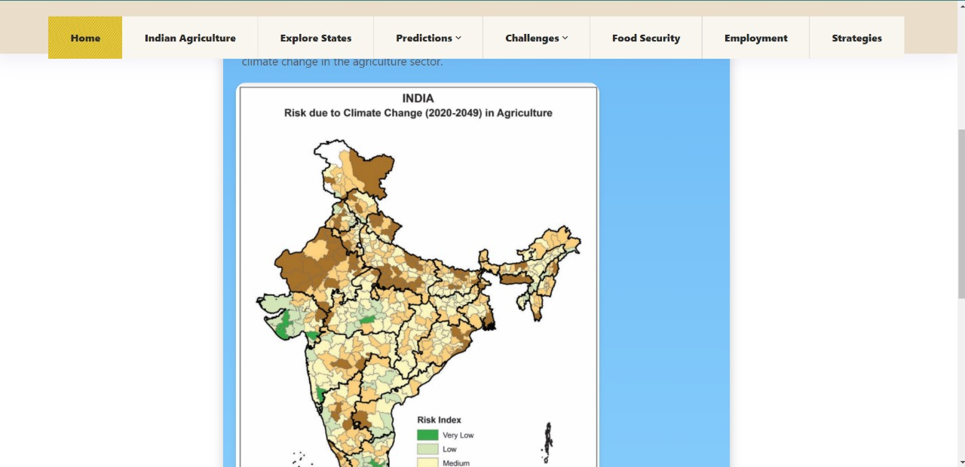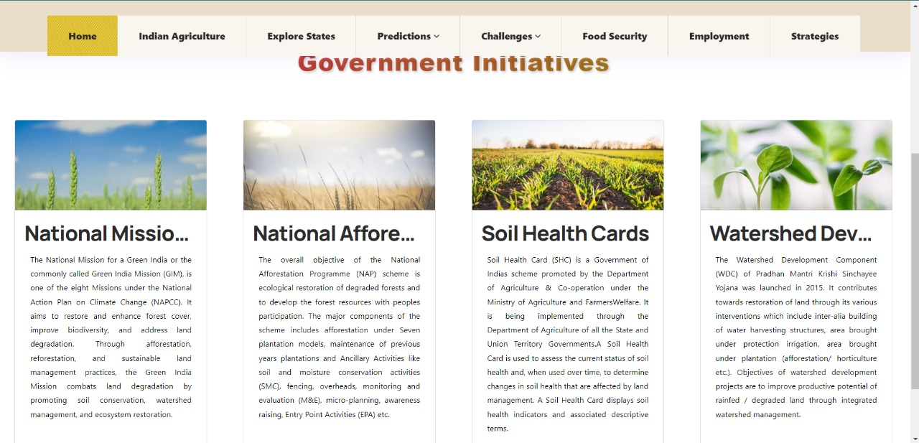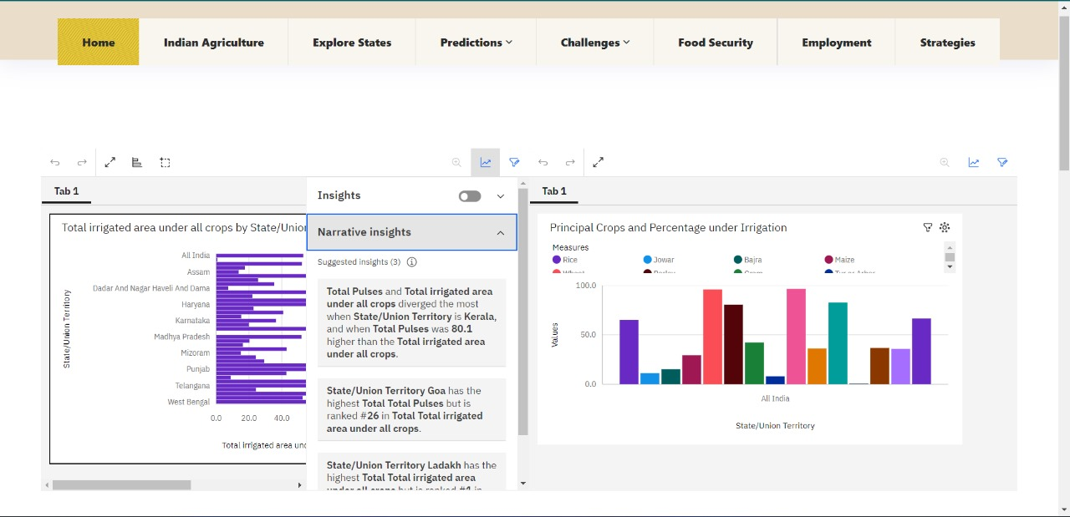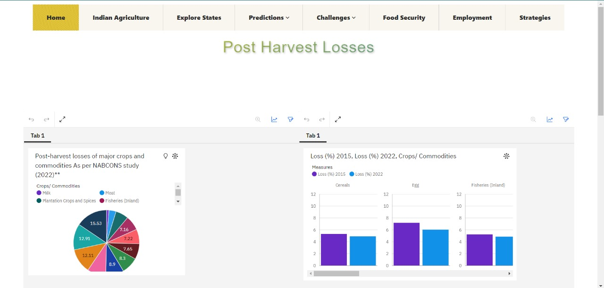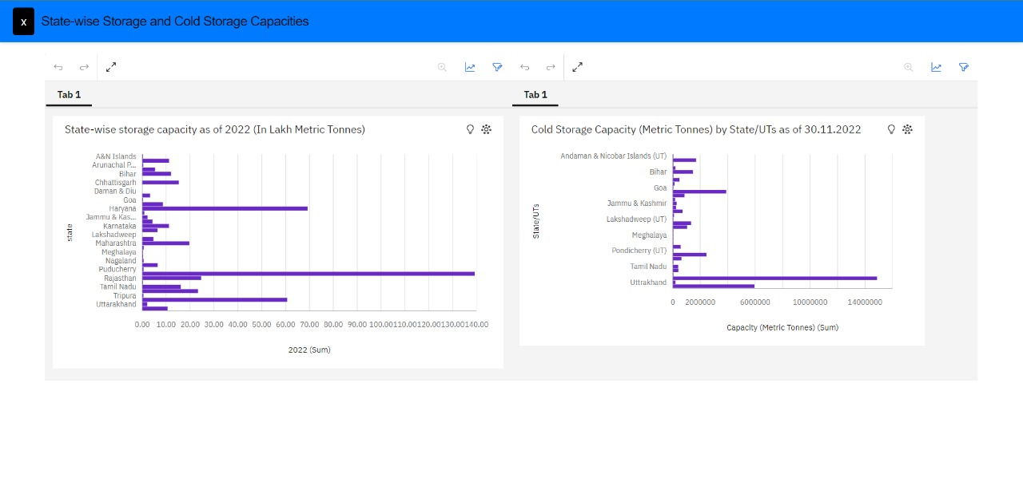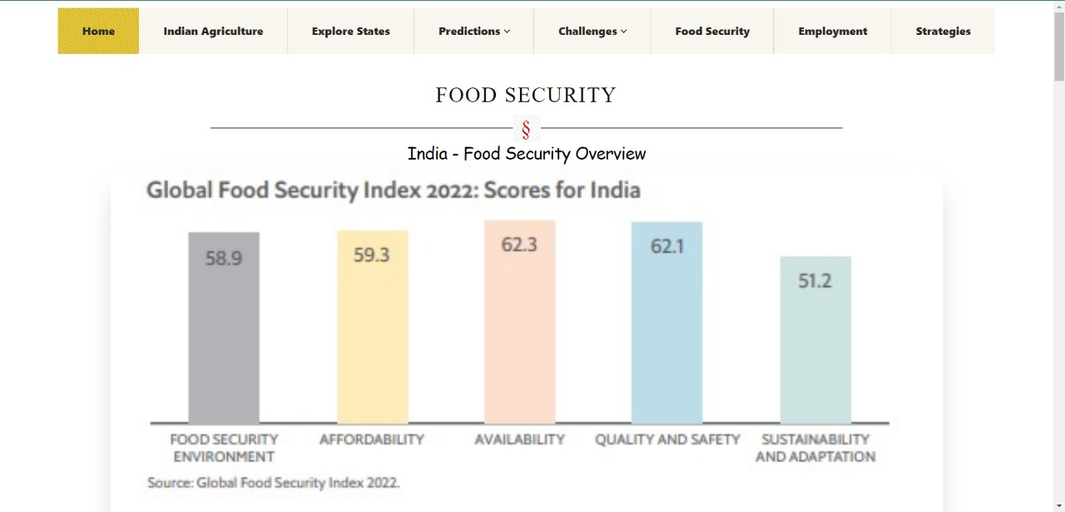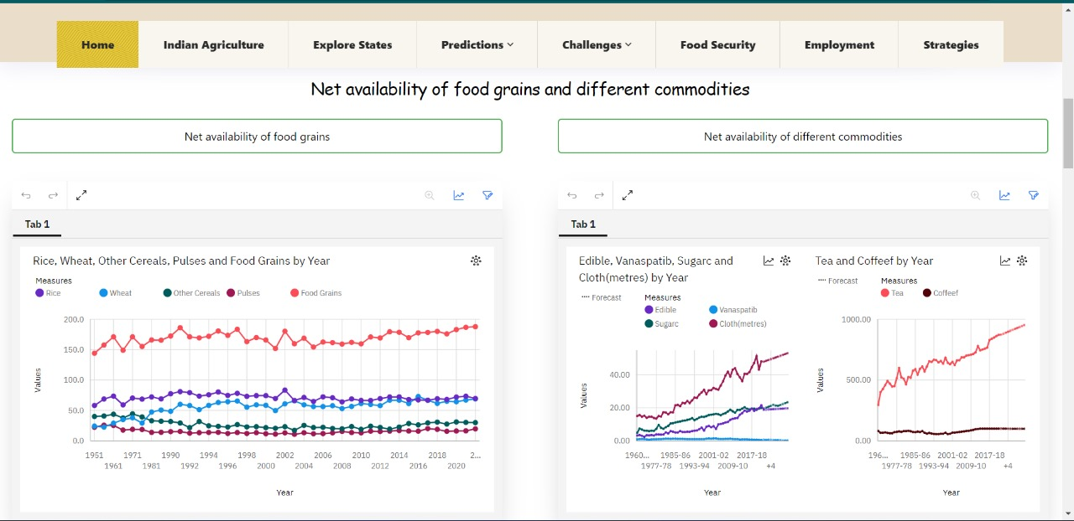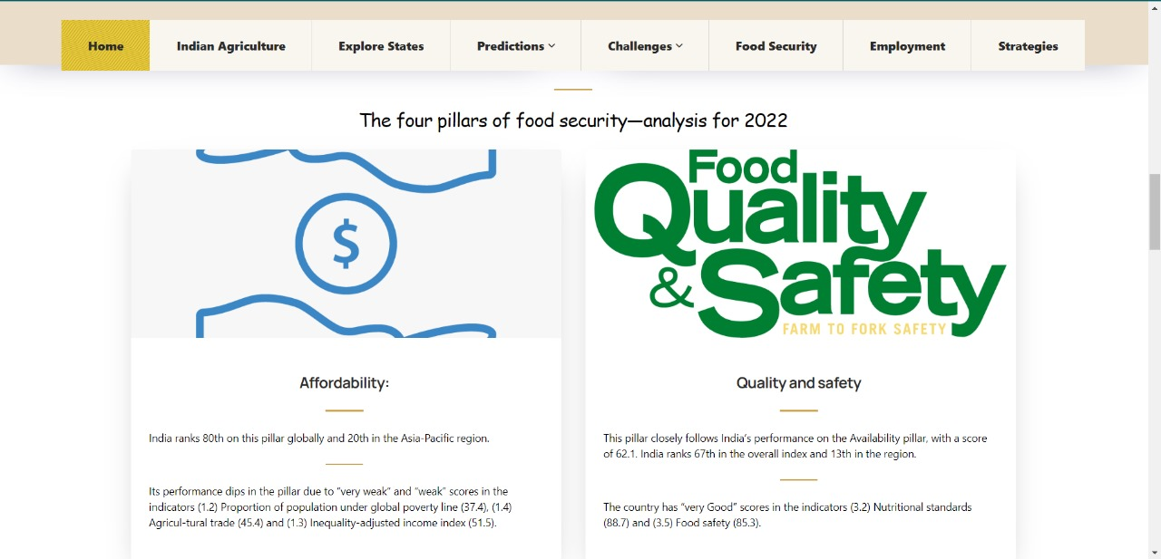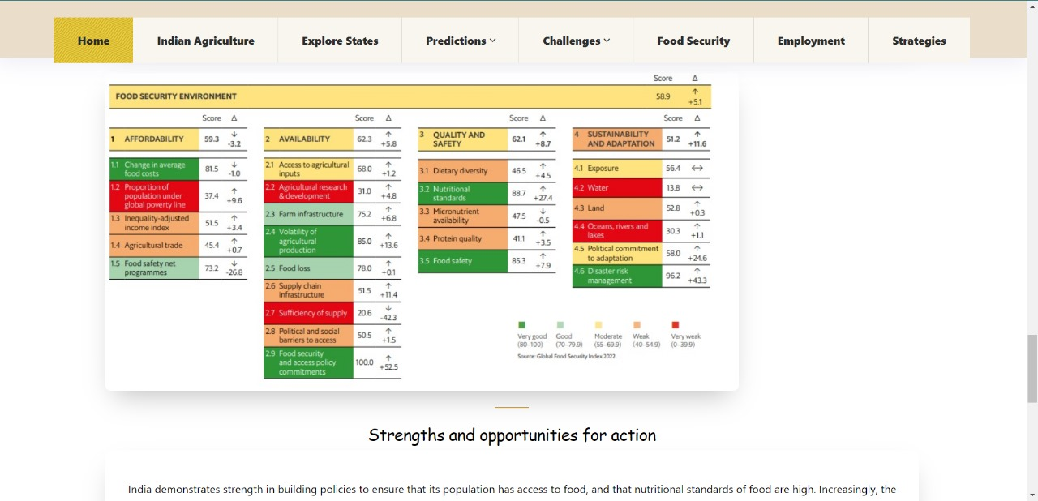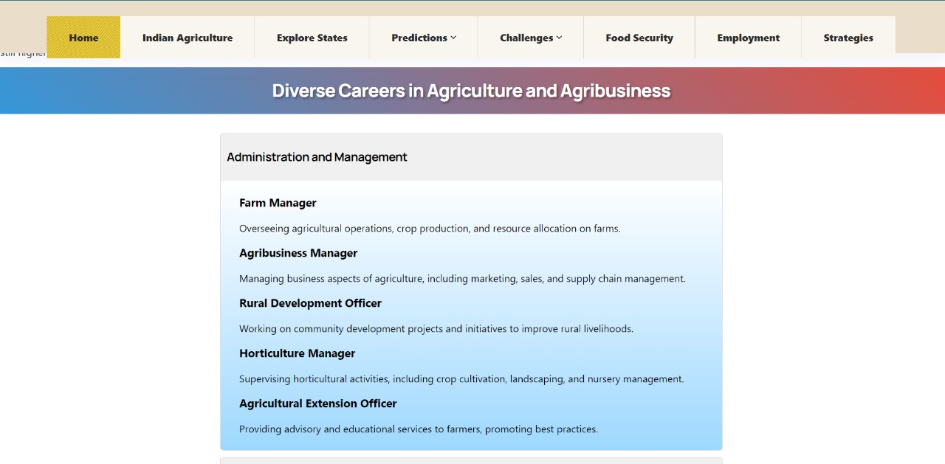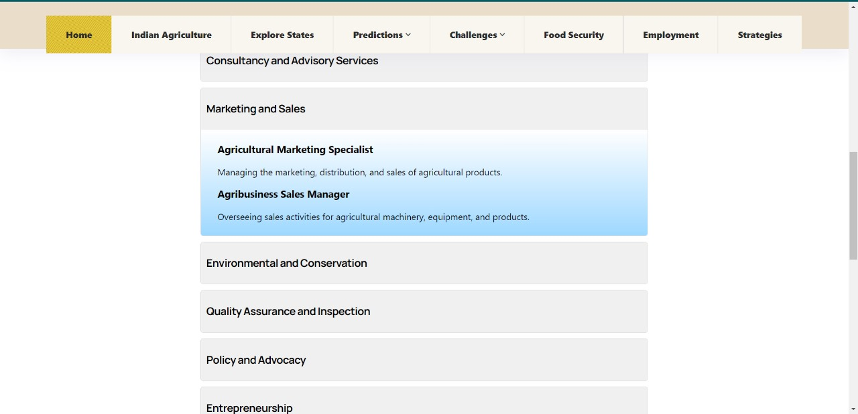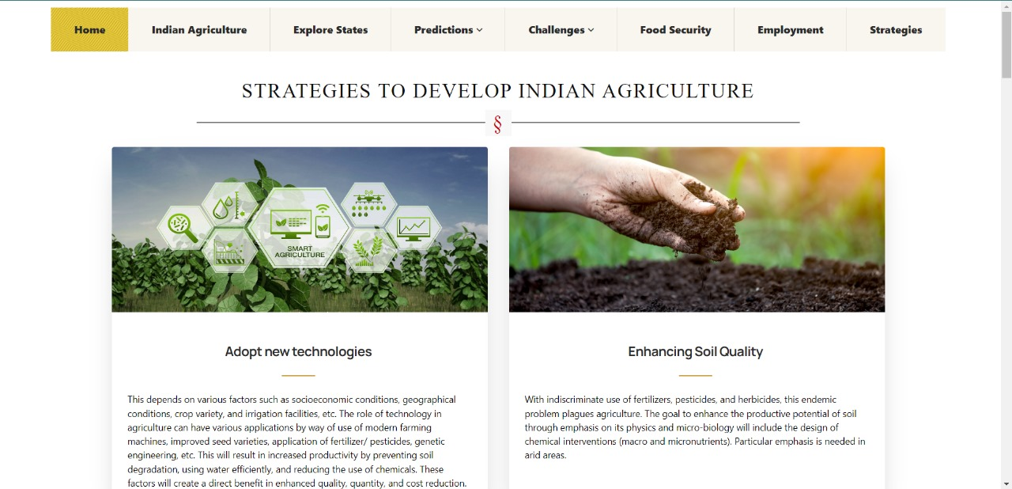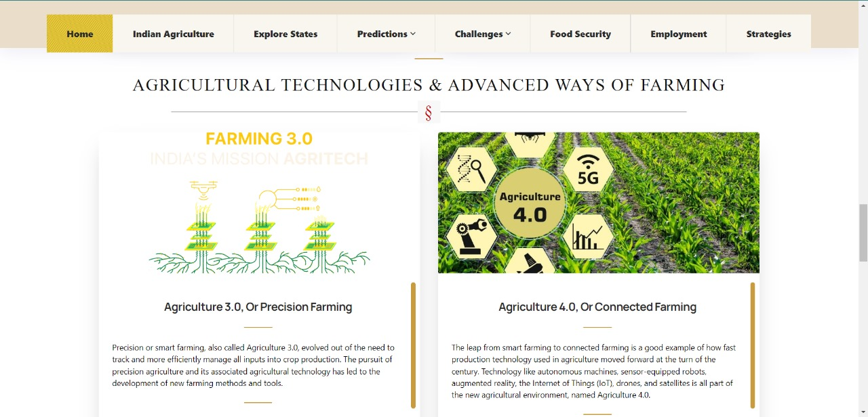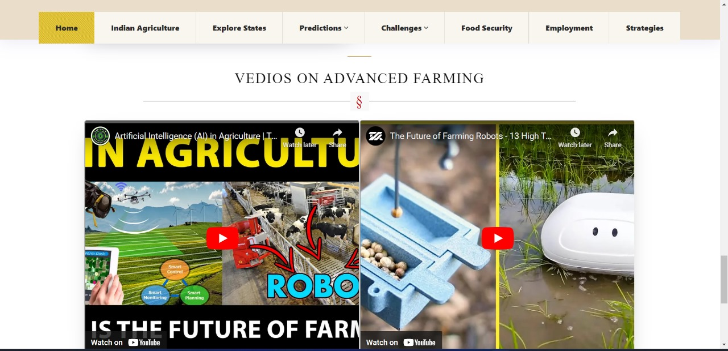

**7. ADVANTAGES & DISADVANTAGES**

**7.1 ADVANTAGES**

* Accurate yield predictions enable farmers to make well-informed decisions about planting, irrigation, fertilization, and harvest timing.
* Detailed analysis of Indian agriculture
* Deeper analysis of Indian Agriculture through State-wise agricultural analysis
* Farmers can allocate resources like water, fertilizers, and labor more efficiently based on predicted yields.
* Predictive models help farmers plan for potential yield fluctuations due to weather changes or other factors.
* Market segmentation for several types of agricultural allied sectors
* Accurate yield forecasts enable better market planning, preventing oversupply or undersupply situations.
* Farmers can use yield predictions to estimate their production cost for the season.
* Yield predictions provide insights into long-term trends in crop performance, aiding farmers in making decisions that impact their land use and crop choices.
* As climate change affects weather patterns, accurate yield predictions assist farmers in adapting their practices to evolving conditions, ensuring continued productivity.

**7.2 DISADVANTAGES**

* Unpredictable events like Natural disasters may affect the crop yields.
* Errors in weather forecasting can affect the reliability of yield predictions.
* Lack of adoption to modern technologies over traditional methodologies.

**8. APPLICATIONS**

* Accurate yield predictions help in market planning to prevent shortages or overproduction.
* Predictions help farmers in planning labor requirements, equipment usage, and other management decisions for optimal yield outcomes.
* Provide insights for farmers to adapt their practices and crops by shifting according to weather and climatic conditions.
* Allow farmers to estimate the cost of production and plan finances accordingly.
* Market segmentation for distinct types of agricultural allied sectors

**9. CONCLUSION**

Agriculture and associated businesses are critical to the economy's long-term development and prosperity. The key difficulties for agricultural production are decision making, crop selection, crop price, and supporting systems for enhanced crop output. The proposed technique helps farmers in decision making of which crop to cultivate in the field. This work is employed to search out the gain knowledge about the crop that can be deployed to make an efficient and useful harvesting. The accurate prediction of different specified crops across different districts will help farmers of India. This improves our Indian economy by maximizing the yield rate of crop production. With an increase in data, we can also increase accuracy. We made this project end-to-end so that farmers can directly use our web to decide which new crops to try out in a certain field that will bring maximum profits and income. The model improved by integrating this with other departments like horticulture, sericulture, and others towards the agricultural development of our country

**10. FUTURE SCOPE**

The future of crop yield prediction using machine learning lies in its potential to revolutionize agriculture by offering data-driven insights for more efficient, sustainable, and secure food production. As technology advances and more data becomes available, the potential for enhancing crop yield prediction using machine learning is vast. So, develop models that explicitly consider the effects of climate change on crop growth, integrate data contributed by farmers themselves, creating a collaborative platform where farmers can input local observations and practices to enhance model accuracy, combine traditional statistical approaches with machine learning techniques for a comprehensive approach to yield prediction, leveraging the strengths of both methodologies. These future directions aim to refine existing models, expand their capabilities, and ensure their practical applicability to benefit farmers, and the Indian agricultural sector.

**11. BIBILOGRAPHY**

**11.1 REFERENCES**

* A survey on different data mining techniques for crop yield prediction Int. J. Computer. Sci. Eng., 7 (1) (2019), pp. 738-744 <https://doi.org/10.26438/ijcse/v7i1.738744>
* N. Nandhini and J. G. Shankar, "Prediction of crop growth using machine learning based on seed", *Intact journal on soft computing*, vol. 11, no. 01, 2020.
* Basso, B. & Liu, L. Chapter four—Seasonal crop yield forecast: Methods, applications, and accuracies. In *Advances in Agronomy* Vol. 154 (ed. Sparks, D. L.) 201–255 (Academic Press, Cambridge, 2019)
* Abhishek, K., Singh, M., Ghosh, S., and Anand, A. (2012). Weather forecasting model using artificial neural network. *Procedia Technol.* 4, 311–318. doi: 10.1016/j.protcy.2012.05.047
* Dahikar S and Rode S V 2014 Agricultural crop yield prediction using artificial neural network approach International Journal of Innovative Research in Electrical, Electronics, Instrumentation and Control Engineering vol 2 Issue 1 pp 683-6.
* Sellam V, and Poovammal E 2016 Prediction of crop yield using regression analysis Indian Journal of Science and Technology vol 9(38) pp 1-5.

**11.2 APPENDIX**

**Source Code:**

[**https://github.com/Keshava369/induce_src.git**](https://github.com/Keshava369/induce_src.git)

**Website link:**

**https://agrolytics-ibmhack.netlify.app/**